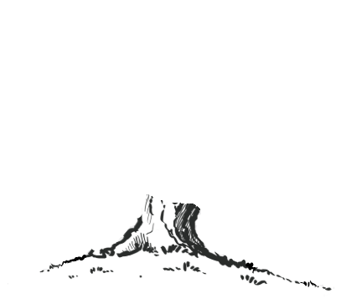
Science
I am a scientist
Mathematics
Place value (within 20)
Addition and Subtraction (within 20)
Place value (within 100)
Shape
Reception: Place value (within 5)
Nursery: Colours, matching, sorting, patterns, numbers (within 2)
Geography
Outdoor adventures
History
A peak into the past
Religious Education
What makes us special?
Why are some people special?
PSHE
Being me in my world
Celebrating differences
French

N/A
English
Spelling: Statutory spelling words/Spelling Shed/Phonics
Reading: Mix of fiction and non-fiction texts linked to wider curriculum learning
Class novels: Daily chosen books
English topics:
Oral retell, Adventure story, Biography, Traditional tales and Instructions
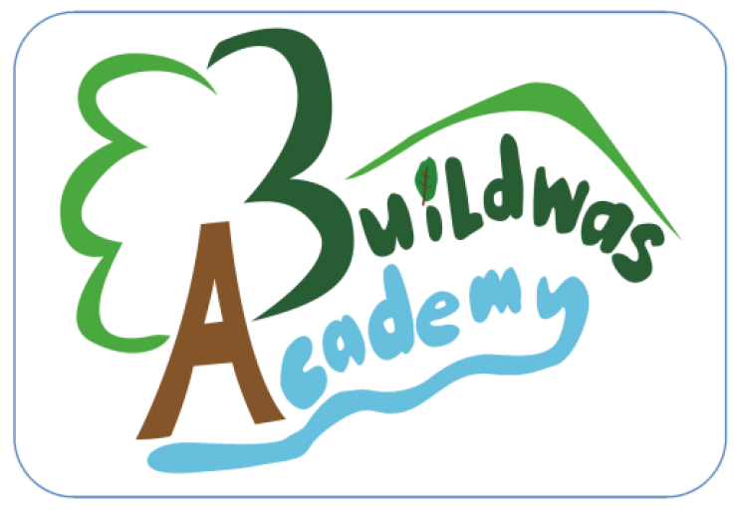
Willow Class

Computing

Programming – All about instructions
Programming – Bee-Bots
Music
Exploring sound

Musical stories
Design Technology
Structures: Junk modelling
Art
Drawing: Marvellous marks
Physical Education
PE days: Monday and Wednesdays
PE topics: Orienteering, Netball, Football, Tag Rugby

