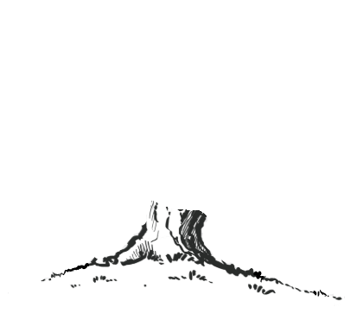
Science
Rocks and soils
Movement and nutrient
Mathematics
Place value
Addition and Subtraction
Multiplication and Division A
Fractions A
Multiplication and division B
Geography
What are rivers and how are they used?
History
British History 1
Would you rather live in the Stone age, Bronze age or Iron age?
Religious Education
Where do we get our morals from?
Is scripture central to Religion?
PSHE
Being me in my world
Celebrating differences
French
French greetings with puppets
Playground games
French adjectives of colours, sizes and shapes
English
Spelling: Statutory spelling words/Spelling Shed
Reading: Mix of fiction and non-fiction texts linked to wider curriculum learning
Class novels: Race to the Frozen North and others
English topics:
Recount, Biography, Narrative, Poetry

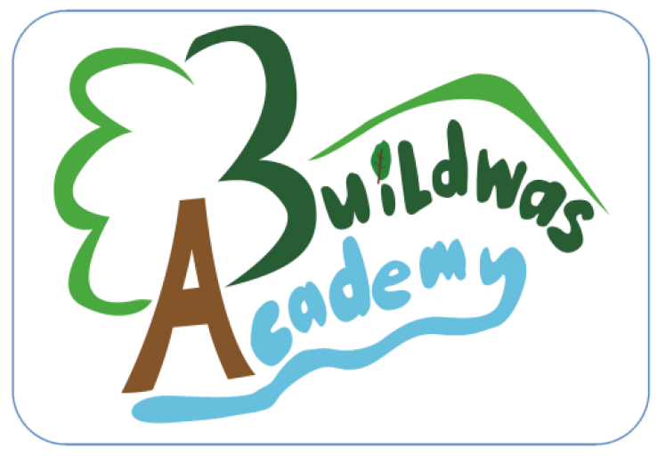
Holly Class

Computing

Programming Scratch
Music
Mountain melodies – steps and leaps

Inspired by India – Musical improvisations
Design Technology
Textiles: Cushions or Egyptian collars
Art
Drawing: Developing drawing skills
Physical Education
PE days: Monday and Wednesdays
PE topics: Orienteering, Netball, Football, Tag Rugby

