Friday 10th March 2023
LT: To use VIPERS skills when reading and discussing the text The Legend Of Spud Murphy .
Vocabulary | Infer | Predict | Explain | Retrieve | Summarise

Bronze
1.How many boys live in the house?
2.Why couldn’t the boys have friends over any more?
3.What is the name of the narrator?

Silver
1.

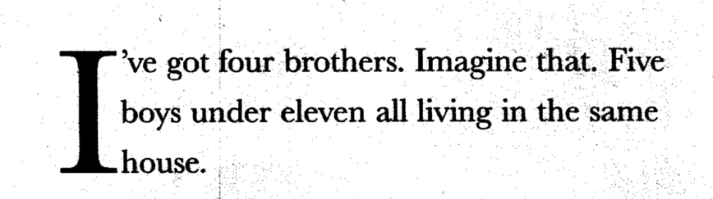
Do you like this as an opening? What impact does it have on the reader?
2. “That’s not fair!” said Marty, the biggest brother, mascara streaking his cheeks.
Why was mascara streaking Marty’s cheeks?

Explain why you think the author/illustrator chose to include these

Gold
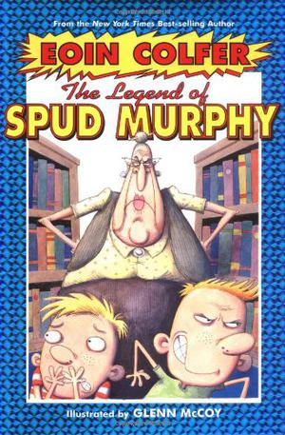
1. Here are two different covers that the book has had. Using these and what you have read, predict what the rest of the story is about.
